Writing up a Practical Report
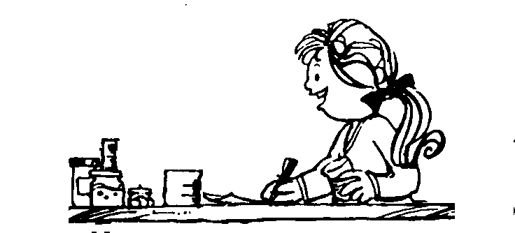

Scientists write up the results of their experiments and observations in a practical report. The following headings are often used in a practical report:

Aim - states the problem or purpose of the experiment. Often the hypothesis is stated as the aim.

Equipment - a list of the apparatus used in the experiment

Method - a step-by-step list of what was done in the experiment. This is written in the past tense and in sufficient detail so that someone else could repeat the experiment.

Diagrams - showing how the apparatus was set up are often used. Completed in pencil and it is labelled with arrows.

Results/Observations - shows your observations and measurements, often presented in a table or as a graph.

Conclusion - this is the answer to the aim or problem being investigated. States what happened, supports it with evidence and explains why: scientific understandings

Title of Experiment: ____________________________

Date conducted: ______________________________

AIM:
To investigate….
EQUIPMENT:

METHOD:

DIAGRAM

RESULTS/OBSERVATIONS

CONCLUSION

